**COOKBOOK: Your Virtual Kitchen Assistant**

**(React Application)**

**ABSTRACT**

CookBook is a web-based application designed to enhance the culinary experience for users by offering an intuitive platform for discovering, organizing, and creating recipes. It caters to both novice cooks and professional chefs with an easy-to-navigate interface and a vast collection of international and dietary-specific recipes. CookBook leverages modern technologies such as React.js, Axios, and external APIs like MealsDB to deliver a dynamic and user-friendly platform for exploring culinary inspirations. The need for CookBook arises from the desire to simplify recipe discovery and organization, as many cooking platforms tend to be either overly complicated or limited in functionality. CookBook fills this gap by offering a comprehensive yet simple tool that enhances cooking creativity, offers variety, and provides inspiration for home cooks and professionals alike. The application utilizes a powerful backend connected to external APIs that provide recipe data, while the frontend ensures a smooth user experience with React.js. Axios is used for fetching data, and React Router handles seamless navigation. Users can explore categories, view trending dishes, and easily access recipes with detailed ingredients, preparation instructions, and tutorial videos. In essence, CookBook is a holistic solution for culinary enthusiasts, answering the needs of a diverse audience by offering both variety and ease of use in a modern web application.

**1.INTRODUCTION**

**Project Title :**

**COOKBOOK:** Your Virtual Kitchen Assistant(React Application)

**Team Members:**

1. Jeevitha.G(Team Leader) – Video Making

2. Parimala.G - Coading

3. Vidhya Devi.K - Documentation

4. Athifa Farhana.M- Documentation

**2.PROJECT OVERVIEW**

**Purpose:**

**Recipe Discovery & Inspiration**: CookBook serves as a hub for culinary exploration, offering users an extensive collection of recipes to browse and get inspired. It allows individuals to search for recipes easily and discover new culinary ideas, helping users break free from mealtime monotony.

**User-Centric Experience:** The platform focuses on delivering an intuitive and seamless experience for users of all skill levels, from beginners to seasoned chefs. Its user interface is designed to be accessible and easy to navigate, encouraging users to interact with the platform regularly.

**Collaboration & Community**: CookBook's vision includes fostering a vibrant community of food lovers who share a passion for cooking. By enabling users to collaborate, share recipes, and engage with one another, it turns cooking into a social, shared experience, which adds an element of fun and community to the culinary journey.

**Simplified Recipe Management:** The platform aims to streamline how users organize and manage their recipes, providing them with tools that make it easier to store, modify, and track recipes. This enhances efficiency, ensuring that users can quickly access their favorite meals when needed.

**Accessibility for All:** The platform is designed for a broad audience, ensuring that both beginners and experienced chefs can find value. Whether someone is new to cooking or has years of experience, CookBook aims to meet their needs and enhance their culinary journey.

**Features:**

**✓** Recipes from the MealsDB API: Access a vast library of international recipes spanning diverse cuisines and dietary needs.

**✓** Visual recipe browsing: Explore recipe categories and discover new dishes through curated image galleries.

**✓** Intuitive and user-friendly design:

Navigate the app effortlessly with a clean, modern interface and clear navigation.

**✓** Search feature: various dishes can be accessed easily through the search feature.

**3.TECHNICAL ARCHITECTURE**

**Component Structure:**

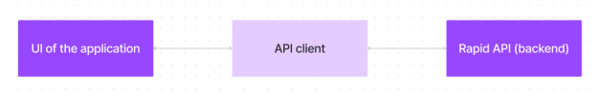

The user experience starts with the CookBooks web application's UI, likely built with a framework like React or Vue.js for a smooth, single-page experience. This UI interacts with an API client specifically designed for CookBooks. This client handles communication with the backend, but with a twist: it leverages Rapid API, a platform providing access to various external APIs.

**State Management:**

state managenent in the CookBook web application, you'll need a robust and scalable system that handles various user interactions, data flow, and UI updates in real-time. Given that CookBook will likely be a dynamic and interactive application with many features, it's important to choose the right state management approach that ensures smooth user experiences and efficient handling of data. Here are some key strategies and concepts for managing state in the CookBook app:

**1. Global State Management**

To keep track of the core application states that are shared across multiple components, you should consider a **centralized state management** approach. Some popular libraries for managing global state include:

* **Redux**: A predictable state container for JavaScript apps, ideal for managing complex global states. Redux will help maintain a central store of data, like the list of recipes, user preferences, and shopping lists. Actions and reducers can manage updates to the state based on user interactions.
* **Context API** (for simpler apps): A React feature that allows you to pass state across the component tree without having to pass props down manually at every level. It’s less boilerplate than Redux but might be suitable for a simpler app with less complex state requirements.

**Core features for global state:**

* **User Authentication State**: Store user login status, user profile, preferences, and session details.
* **Recipe Data**: Keep track of saved recipes, customizations, ingredient lists, and meal plans.
* **Shopping Lists**: Manage lists of ingredients and shopping data, which can be shared across devices.

**2. Local Component State**

For managing local, isolated states within individual components (e.g., form inputs, dropdown selections, toggle states), you can rely on React’s built-in state management using useState or useReducer. This keeps the state localized to the specific component and doesn't require the entire app to re-render.

**Examples of local state:**

* **Recipe Modal**: Whether the modal for creating or viewing a recipe is open.
* **Filters**: Managing search/filter parameters, like cuisine type, difficulty, or ingredients.
* **Form Inputs**: For user input such as adding ingredients to a recipe, editing a recipe, or managing profile data.

**3. Asynchronous Data Handling**

Managing asynchronous operations like fetching recipes, user data, or shopping list data is crucial in CookBook. To manage these asynchronous actions effectively, you can implement one of the following strategies:

* **Thunk Middleware (with Redux)**: Redux Thunk allows you to write action creators that return a function instead of an action, enabling async dispatching and side effects (e.g., API calls).
* **React Query**: React Query is a popular library to manage server-side data fetching and caching. It simplifies asynchronous state management by handling data fetching, caching, and syncing.
* **useEffect & useState (for simple cases)**: Use useEffect in combination with useState to fetch data from APIs and manage loading states or error handling.

**Routing**

In a **React-based app** (which is common for modern web apps), **React Router** is the go-to library for handling routing. It allows you to define routes and link different components together based on the URL. Here’s a guide on how you can implement routing for CookBook using **React Router**.

**1. Install React Router**

To get started, you'll need to install **React Router**:

bash

Copy

npm install react-router-dom

**2. Basic Setup with React Router**

Once React Router is installed, you can configure routing for the app. Here’s how you can set up the basic routing structure:

js

Copy

// App.js

import React from 'react';

import { BrowserRouter as Router, Route, Switch } from 'react-router-dom';

import HomePage from './pages/HomePage';

import RecipeSearchPage from './pages/RecipeSearchPage';

import RecipeDetailPage from './pages/RecipeDetailPage';

import UserProfilePage from './pages/UserProfilePage';

import Navbar from './components/Navbar';

function App() {

return (

<Router>

<Navbar /> {/* Navigation bar that remains constant across pages */}

<Switch>

<Route exact path="/" component={HomePage} />

<Route path="/recipes" component={RecipeSearchPage} />

<Route path="/recipe/:id" component={RecipeDetailPage} />

<Route path="/profile" component={UserProfilePage} />

</Switch>

</Router>

);

}

export default App;

**3. Defining Routes**

In the example above:

* **<Router>**: Wrapping the entire app in the Router component makes routing available to the entire application.
* **<Switch>**: Ensures only one route is matched and rendered at a time.
* **<Route>**: Defines specific paths that render certain components.

**4. Example Pages and Components**

1. **HomePage Component**

js

Copy

// pages/HomePage.js

import React from 'react';

import { Link } from 'react-router-dom';

const HomePage = () => {

return (

<div>

<h1>Welcome to CookBook!</h1>

<p>Find the best recipes and start cooking today!</p>

<Link to="/recipes">Browse Recipes</Link>

</div>

);

};

**4.SETUP INSTRUCTIONS**

**PRE-REQUISITES**

Here are the key prerequisites for developing a frontend application using React.js:

**✓ Node.js and npm**

Node.js is a powerful JavaScript runtime environment that allows you to run JavaScript code on the local environment. It provides a scalable and efficient platform for building network applications. Install Node.js and npm on your development machine, as they are required to run JavaScript on the server-side.

**INSTALLATION:**

• Installation of required tools:

To build CookBook, we'll need a developer's toolkit. We'll use React.js for the interactive interface, React Router Dom for seamless navigation, and Axios to fetch news data. For visual design, we'll choose either Bootstrap or Tailwind CSS for pre-built styles and icons.

Open the project folder to install necessary tools, In this project, we use:

* React Js
* React Router Dom
* React Icons
* Bootstrap/tailwind css
* Axios

**• Installation instructions**: <https://nodejs.org/en/download/package-manager/>

**5.Folder structure**

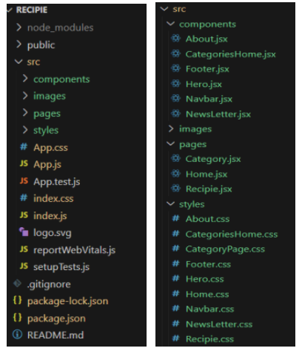

In this project, we’ve split the files into 3 major folders, Components, Pages and Styles. In the pages folder, we store the files that acts as pages at different url’s in the application. The components folder stores all the files, that returns the small components in the application. All the styling css files will be stored in the styles folder.

**CLIENT:**

**Project Development**

❖ Setup the Routing paths

Setup the clear routing paths to access various files in the application.

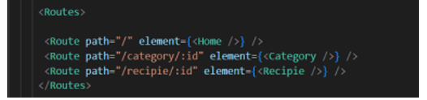

❖ Develop the Navbar and Hero components

❖ Code the popular categories components and fetch the categories from themealsdb Api.

❖ Also, add the trending dishes in the home page.

❖ Now, develop the category page to display various dishes under the category.

❖ Finally, code the recipe page, where the ingredients, instructions and a demo video will be integrated to make cooking much easier.

**UTILITES:**

**IMPORTANT CODE SNIPS**

**➢** Fetching all the available categories

Here, with the API request to Rapid API, we fetch all the available categories.

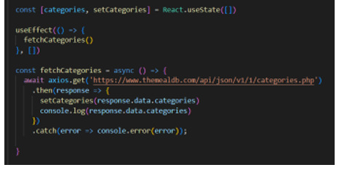

This code snippet demonstrates how to fetch data from an API and manage it within a React component. It leverages two key functionalities: state management and side effects.

**State Management with useState Hook:**

The code utilizes the useState hook to create a state variable named categories. This variable acts as a container to hold the fetched data, which in this case is a list of meal categories. Initially, the categories state variable is set to an empty array [].

**Fetching Data with useEffect Hook**:

The useEffect hook is employed to execute a side effect, in this instance, fetching data from an API. The hook takes a callback function (fetchCategories in this case) and an optional dependency array. The callback function is invoked after the component renders and whenever the dependencies in the array change. Here, the dependency array is left empty [], signifying that the data fetching should occur only once after the component mounts.

**Processing API Response:**

The .then method is chained to the axios.get call to handle a successful response from the API. Inside the .then block, the code retrieves the categories data from the response and updates the React component's state using the setCategories function. This function, associated with the useState hook, allows for modification of the categories state variable. By calling setCategories(response.data.categories), the component's state is updated with the fetched list of meal categories.

**➢ Fetching the food items under a particular category**

Now, with the API request, we fetch all the available food items under the certain category.

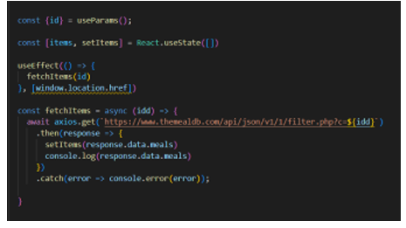

This React code snippet manages data fetching from an API.

● It leverages the useState hook to establish a state variable named categories. This variable acts as a container to hold the fetched data, which is initially set to an empty array [].

● The useEffect hook comes into play to execute a side effect, in this instance, fetching data from an API endpoint. The hook takes a callback function (fetchCategories in this case) and an optional dependency array. The callback function is invoked after the component renders and whenever the dependencies in the array change. Here, the dependency array is left empty [], signifying that the data fetching should occur only once after the component mounts.

● The fetchCategories function is an asynchronous function responsible for handling the API interaction. This function utilizes the axios.get method to make a GET request to a predetermined API endpoint (https://www.themealdb.com/api/json/vi/1/categories.php in this example). This particular endpoint presumably returns a JSON response containing a list of meal categories.

● The code snippet employs the .then method, which is chained to the axios.get call, to handle a successful response from the API. Inside the .then block, the code retrieves the categories data from the response and updates the React component's state using the setCategories function. This function, associated with the useState hook, allows for modification of the categories state variable. By calling setCategories(response.data.categories), the component's state is updated with the fetched list of meal categories.

● An optional error handling mechanism is incorporated using the .catch block. This block is designed to manage any errors that might arise during the API request. If an error occurs, the .catch block logs the error details to the console using the console.error method. This rudimentary error handling mechanism provides a way to identify and address potential issues

**➢ Fetching Recipe details**

With the recipe id, we fetch the details of a certain recipe.

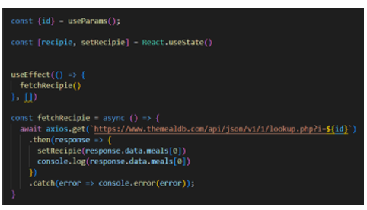

This React code manages fetching recipe data from an API and storing it within a state variable.

● It leverages the useState hook to establish a state variable named recipie (which is initially empty). This variable acts as a container to hold the fetched recipe data.

● The useEffect hook comes into play to execute a side effect, in this instance, fetching data from an API endpoint. The hook takes a callback function (fetchRecipie in this case) and an optional dependency array. The callback function is invoked after the component renders and whenever the dependencies in the array change. Here, the dependency array is left empty [], signifying that the data fetching should occur only once after the component mounts.

● The fetchRecipie function is an asynchronous function responsible for handling the API interaction. This function likely utilizes the axios.get method to make a GET request to a predetermined API endpoint, the exact URL construction of which depends on a recipeId retrieved from somewhere else in the code (not shown in the snippet).

● The code snippet employs the .then method, which is chained to the axios.get call, to handle a successful response from the API. Inside the .then block, the code retrieves the first recipe from the data.meals array in the response and updates the React component's state using the setRecipie function. This function, associated with the useState hook, allows for modification of the recipie state variable. By calling setRecipie(response.data.meals[0]), the component's state is updated with the fetched recipe data, effectively making it available for use throughout the component.

● An optional error handling mechanism is incorporated using the .catch block. This block is designed to manage any errors that might arise during the API request. If an error occurs, the .catch block logs the error details to the console using the console.error method. This rudimentary error handling mechanism provides a way to identify and address potential issues during the data fetching process.

**6.RUNNING THE APPICATION**

**✓ React.js**

React.js is a popular JavaScript library for building user interfaces. It enables developers to create interactive and reusable UI components, making it easier to build dynamic and responsive web applications. Install React.js, a JavaScript library for building user interfaces

• Create a new React app:

npx create-react-app my-react-app

Replace my-react-app with your preferred project name

• Navigate to the project directory:

cd my-react-app

• Running the React App:

With the React app created, you can now start the development server and see your React application in action.

• Start the development server:

npm start

This command launches the development server, and you can access your React app at http://localhost:3000 in your web browser.

**Frontend:**

**✓ HTML, CSS, and JavaScript:** Basic knowledge of HTML for creating the structure of your app, CSS for styling, and JavaScript for client-side interactivity is essential.

**✓ Development Environment:** Choose a code editor or Integrated Development Environment (IDE) that suits your preferences, such as Visual Studio Code, Sublime Text, or WebStorm.

**7.COMPONENT DOCUMENTATION**

**Project setup and configuration.**

**• Installation of required tools:**

To build Cook Book, we'll need a developer's toolkit. We'll use React.js for the

Interactive interface, React Router Dom for seamless navigation, and AXIOS to fetch news data. For visual design, we'll choose either Bootstrap or Tailwind CSS for pre-built styles and icons.

Open the project folder to install necessary tools, this project, we use:

o React JS

o React Router Dom

o React Icons

o Bootstrap/tailwind CSS

o AXIOS

• For further reference, use the following resources

o <https://react.dev/learn/installation>

o <https://react-bootstrap-v4.netlify.app/getting-started/introduction>

o <https://axios-http.com/docs/intro>

o <https://reactrouter.com/en/main/start/tutorial>

**8.STATE MANAGEMENT**

**1. Global State Management**

To keep track of the core application states that are shared across multiple components, you should consider a **centralized state management** approach. Some popular libraries for managing global state include:

* **Redux**: A predictable state container for JavaScript apps, ideal for managing complex global states. Redux will help maintain a central store of data, like the list of recipes, user preferences, and shopping lists. Actions and reducers can manage updates to the state based on user interactions.
* **Context API** (for simpler apps): A React feature that allows you to pass state across the component tree without having to pass props down manually at every level. It’s less boilerplate than Redux but might be suitable for a simpler app with less complex state requirements.

**Core features for global state:**

* **User Authentication State**: Store user login status, user profile, preferences, and session details.
* **Recipe Data**: Keep track of saved recipes, customizations, ingredient lists, and meal plans.
* **Shopping Lists**: Manage lists of ingredients and shopping data, which can be shared across devices.

**2. Local Component State**

For managing local, isolated states within individual components (e.g., form inputs, dropdown selections, toggle states), you can rely on React’s built-in state management using useState or useReducer. This keeps the state localized to the specific component and doesn't require the entire app to re-render.

**Examples of local state:**

* **Recipe Modal**: Whether the modal for creating or viewing a recipe is open.
* **Filters**: Managing search/filter parameters, like cuisine type, difficulty, or ingredients.
* **Form Inputs**: For user input such as adding ingredients to a recipe, editing a recipe, or managing profile data.

**9.USER INTERFACE**

**➢ Hero components**

The hero component of the application provides a brief description about our application and a button to view more recipes.

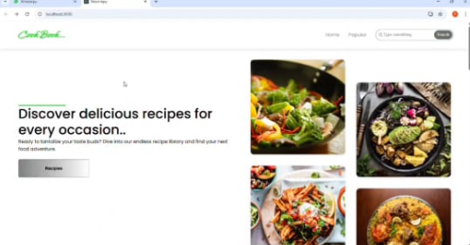

**➢ Popular categories**

This component contains all the popular categories of recipes..

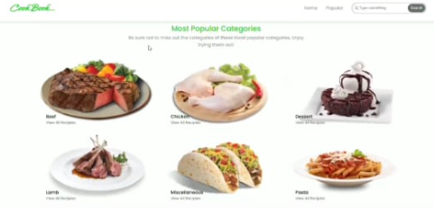

**➢ Trending Dishes**

This component contains some of the trending dishes in this application.

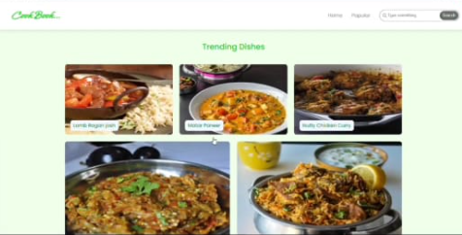

**➢ News Letter**

The news letter component provides an email input to subscribe for the recipe newsletters.

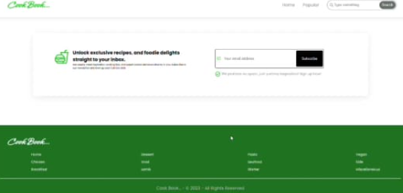

**➢ Category dishes page**

The category page contains the list of dishes under a certain category.

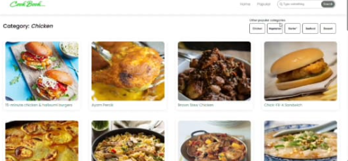

**➢ Recipe page**

The images provided below shows the recipe page, that includes images, recipe instructions, ingredients and even a tutorial video.

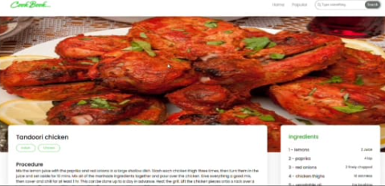

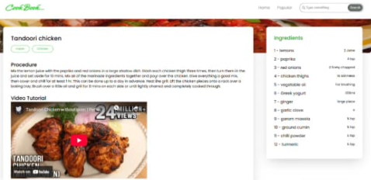

**10.STYLING**

CSS Frameworks and Libraries

To expedite the styling process and ensure responsiveness, consider using a CSS framework or utility-first CSS framework:

* Bootstrap: A widely used responsive framework with pre-defined components for easy layout and UI component design. It's simple to implement and provides a range of utility classes for spacing, typography, and responsive design.
* Tailwind CSS: A utility-first CSS framework that provides flexibility in styling. It allows you to build custom designs with a low-level approach. Tailwind will enable you to create a highly customizable design for CookBook.
* Styled Components (if using React): A modern CSS-in-JS library that allows you to write CSS directly in your JavaScript files. It’s perfect for React components and maintaining scoped styles.
* Material UI (for React): A popular component library that follows Google’s Material Design guidelines, offering a rich set of pre-built components.

**11.TESTING**

1. Unit Testing

Purpose: Ensure individual components or functions perform as expected in isolation.

* Focus on small units of functionality, such as individual functions, methods, or components (e.g., recipe search logic, user profile data handling).
* Test for edge cases: Handle situations where users input unexpected or invalid data (e.g., empty search queries, invalid recipe ratings).
* Verify business logic: Ensure the logic that drives your application, such as recipe filtering or meal planning, works correctly.

2. Integration Testing

Purpose: Ensure multiple components or systems work together as expected.

* Verify interactions between different components: Test how your components interact, such as a search input interacting with a list of recipes or the backend API.
* Data flow: Make sure data flows correctly between the frontend and backend. For example, after submitting a search query, the application should display the correct results.
* Test integration with third-party services: If you are using external services (e.g., payment gateways or recipe APIs), test these integrations thoroughly.

3. End-to-End (E2E) Testing

Purpose: Test the full flow of the application from start to finish, mimicking real user behavior.

* Simulate user journeys: Test how a user interacts with the app, from logging in to searching recipes, adding them to favorites, or completing the checkout process.
* Ensure UI consistency: Check that all UI elements (buttons, forms, etc.) are working correctly and as expected across different devices and browsers.
* Test in real user environments: Use tools to run the application on different devices and browsers to simulate real-world use and identify any issues with UI responsiveness or behavior.

4. Visual Regression Testing

Purpose: Ensure that changes in the code do not unintentionally break or alter the UI.

* Track visual changes: Automatically compare screenshots of your app taken before and after code changes to identify any unintended visual differences.
* UI consistency: Ensure that UI components maintain their appearance and layout after updates, especially for things like buttons, images, and navigation.
* Cross-browser testing: Ensure the app's visuals are consistent across different browsers and screen sizes.

5. Performance Testing

Purpose: Measure how well the application performs under normal and heavy load conditions.

* Page load time: Ensure that the app loads quickly and efficiently, especially for recipe-heavy pages or when accessing large amounts of data.
* Responsiveness: Test how the app performs on various network conditions (e.g., slow 3G) and different devices.
* Stress testing: Simulate a high volume of users or data to check the app’s scalability and response times under load.

**12.SCREENSHOT OR DEMO**





DEMOLINK: <https://drive.google.com/file/d/14cQe3Ur9oNnV5JkSkNTlGh3QAVTvXBOg/view?usp=drivesdk>

GITUPLINK: <https://github.com/884578/Cook-Book>

**14.FUTURE ENHANCEMENT**

Here are some future enhancements for your CookBook web application that could elevate the user experience, expand functionality, and cater to evolving user needs:

1. AI-Powered Recipe Suggestions

* Overview: Integrate an AI-driven recommendation engine that can suggest personalized recipes based on user preferences, dietary restrictions, past search history, and even current ingredients in the user's kitchen.
* Features:
  + Personalized recipe recommendations.
  + Recipe suggestions based on mood or occasion (e.g., "comfort food," "quick meals").
  + Intelligent ingredient substitution for users with allergies or dietary preferences.

Impact: This would increase user engagement by offering more tailored suggestions, encouraging repeat visits and increasing satisfaction with the app.

2. Voice Integration for Hands-Free Cooking

* Overview: Enable voice commands within the app for hands-free navigation and cooking assistance.
* Features:
  + Voice search for recipes, ingredients, and meal plans.
  + Step-by-step voice-guided instructions while cooking.
  + Users can ask for specific instructions, like "What should I do next?" or "How much salt should I add?"

Impact: Perfect for users who prefer not to touch their devices while cooking. It can enhance the cooking experience, making it safer and more enjoyable for users with busy hands.

3. Recipe Sharing and Social Community Features

* Overview: Create a social network-like feature where users can share their recipes, rate others' recipes, and follow fellow cooks.
* Features:
  + Recipe sharing with friends, family, or the broader community.
  + Rating and commenting system to build a vibrant cooking community.
  + Recipe challenges and events (e.g., "30-minute dinner challenge").
  + "Follow" functionality to track favorite chefs or recipe creators.

Impact: This feature would foster a sense of community, encouraging users to return, engage with content, and inspire others with their culinary creations.

4. Meal Prep and Grocery List Integration

* Overview: Add features for meal prepping and automatic grocery list generation based on chosen recipes or meal plans.
* Features:
  + Automatically generate a shopping list from selected recipes or meal plans.
  + Meal prep functionality where users can plan out their meals for the week.
  + Integration with grocery stores for easy online shopping (e.g., through APIs like Instacart or Amazon Fresh).
  + Notifications for users to shop for ingredients in advance or when they're running low on staples.

Impact: Helps users save time and streamline their meal planning and shopping processes, making the app more useful in their daily lives.